About
Rivers in the Desert is a concert of works that parallel the African American experience with that of the Hebrew slaves.
…I will even make a way in the wilderness, and rivers in the desert.
Isaiah 43:19, NKJV

If one is to ever inquire of the vast genres of African-American music, he or she must credit the catharsis of the Ring Shout as the primary source whereby all black musical and cultural expressions are rooted. For it was from an oppressed people that a manifestation of rhythm, body movement and song transcended the vicissitudes of the slave experience in America.

"Little of beauty has America given the world save in the rude grandeur God himself stamped on her bosom! The human spirit in this new world has expressed itself in vigor and ingenuity rather than in beauty. And so by fateful chance the Negro folk-song, the rhythmic cry of the slave—stands today not simply as the sole American music, but as the most beautiful expression of human experience born this side the seas. It has been neglected, it has been, and is, half despised, and above all it has been persistently mistaken and misunderstood; but notwithstanding, it still remains as the singular spiritual heritage of the nation and the greatest gift of the Negro people."
- W. E. B. Du Bois, The Souls of Black Folk – 1903, p. 251

The Spirituals
The Work Song is perhaps the most indigenous of the African Diaspora. Historically, they were created by slaves who incorporated rhythm, body movement and song into their daily tasks. Heavy accents on alternating beats helped to synchronize the labor at hand.

As Olly Wilson asserts:

“the process of chopping wood becomes an intrinsic part of the music, wherein the work becomes the music, and the music becomes the work”

These songs often contained codified messages, stories from the Bible, and words of encouragement to one another. From the fervent cries heard in the fields, or improvised rhythmic chants from workers on the docks, and the voices heard from victims of peonage, America was built from their labor and its history hidden in a Song.

Hold On! is an extension of the traditional Work Song. Constructed by the use of the Afro-Cuban rhythm called SON, the character in this piece has been battered by the woes of life. He goes to the present-day ‘Noahs’ for consolation, only to find them too preoccupied with their own lives. However, finding “the link in Mary’s Golden Chain, he regains the strength to encourage himself, as well as others, realizing those who plow should do so in hope.
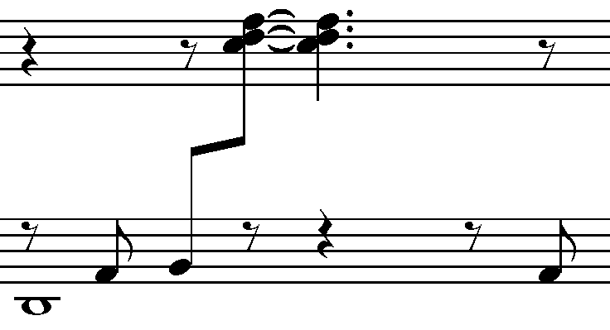

SON rhythm pattern = (3+3+2)

This piece is intended to be quite aggressive throughout. The dissonant chordal passages are indicative, and indeed necessitated to emulate struggle and fortitude. As well, the text has been set in a vernacular connotation reminiscent of African American social and cultural underpinnings.

This setting was written for Alvy Powell who masterfully premiered the work at the pre-opening ceremony for the Smithsonian Museum of African American History and Culture Museum.

Quoting again from Dubois’ The Souls of Black Folk, he speaks of our spiritual strivings: “Among the Sorrow Songs there breathed a hope.”

Jacob’s Ladder is from a collection of chamber spirituals for voice, violoncello and piano. This work was inspired by a visit to the birthplace of Dr. Bethune, located among the ruins of the slave quarters of a plantation home in Mayesville, South Carolina.
I plunged myself into job of creating something from nothing… Though I hadn’t a penny left, I considered cash money as the smallest part of my resources. I had faith in a living God, faith in myself, and a desire to serve.
Mary McLeod Bethune, 1875-1955

The use of the cello presents a solemn representation of what I could only imagine what plantation life was like for the slave. Set in g minor with additive usage of the Phrygian mode, the arpeggiated structure found in the piano accompaniment is replete with contrary rises and falls to emulate the struggle of a climb for humanity. In Bethune’s case, that climb was toward education and the welfare of poor underprivileged girls.

Coding or the use of the double entendre is found in many of the slave songs: “Follow the Drinking Gourd”, “Wade in the Water”, “ Steal Away to Jesus” are all examples of what ethnomusicologist Arthur C. Jones refers to as: The creative geniuses despite slavery. He goes on to say:
The fact that there were also many emotional and physical casualties is not shocking; the fact that there were so many who emerged from their suffering to live on psychological and spiritual “higher ground” is.

It is without doubt that music is the very center of emotion or the expression thereof. Let My People Go! extends beyond the point of physical bondage, as it addresses the current day ‘Pharos” society has allowed to imprison the mind.

Dr. John Wesley Wright premiers this provocative work amid a pallet of Egyptian influences where the accompaniment is equally as important as the text.

Hymns and Gospel Songs
With the church being the center of the black community, the idiom of gospel music began in the late nineteenth and early twentieth century with the hymns of Charles Albert Tindley. Flowing directly out of the reservoir of Negro spirituals, employing the two-part structure of verse and refrain, the trope of call and response, the art of repetition as practiced by slaves in their invisible churches, praise houses and various camp meetings.

The term “gospel” is derived from the synoptic gospels of the New Testament, which records the miracles, teachings, saving and sustaining power of Jesus Christ. The genre becomes crystalized in the 1930s by former blues pianist Thomas A. Dorsey.
With the merging of the elements of blues and the religious fervor of the spiritual, gospel music became the catalyst in which the African-American community sustained themselves through a theology of “somehow”. – Something that keeps you even when you have no idea you’re being kept.

When My Mother Sang… is a triptych of gospel hymn settings my mother sang to me as a child. Among them, an evening hymn:

Have I given anything, today? Have I helped some wounded soul while on my way?
From the dawn ‘til setting sun, have I wounded anyone? Shall I weep for what I’ve done, today?

Have I made some person glad, today? Did I help someone whose had a mortal day?
Did I council with the sad? Did I make some poor heart glad? Answer wisdom, what I’ve had, today? – Thomas A. Dorsey, 1939

Brandie Sutton, Soprano premieres works from this triptych for voice, clarinet / oboe, violoncello, and piano.

Olly Wilson: “Black Music as an Art Form”: The Black Music Research Journal, Volume 3, p. 1983.
Arthur C. Jones, Wade in the Water: The Wisdom of the Spirituals [Maryknoll, NY: Orbis Books, 1993], p. 25

